[2016 cvpr A 3D morphable model learned from 10000 faces]

Contributions:
- Introduced a novel automated and robust Morphable Model construction pipeline.
- The dataset includes rich demographic information about each subject(age, gender, ethnicity groups, and proved to have quality and descriptive power
- Qualitative and quantitative evaluation.
- Demonstrate that large-scale model with accurate demographics enables accurate age classification from 3D shape data alone.

General idea:
Construction of 3DMM consists two steps:
- dense correspondence (training set of facial meshes)
- and performing statistical analysis on registered data to produce low-dimensional model

Dense correspondence: ‘UV’ map(flattening 3D surface down into a 2D space)
Similarity alignment & statistical modeling: PCA generating a 3D deformable model as a linear basis of shapes.
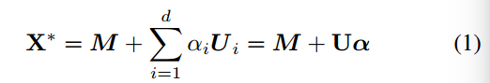
M∈R^{3n} is the mean shape（平均形状）
U=[U1,U2,...Ud]∈R^{3nxd}, orthonormal basis matrix, each column is eigenvectors U_{i}, (酉矩阵的前d列)
α=[α₁,...,α_{d}]∈R^{d} is the shape vector that contains the parameters (coefficients) that define a specific shape instance (特定的实例所具有的参数)

Input 3D mesh X, X can be projected on the model subspace by finding the shape vector α, α generate a shape instance(1), as close as possible to X.
Corresponding projection P(X) on subspace are given by:

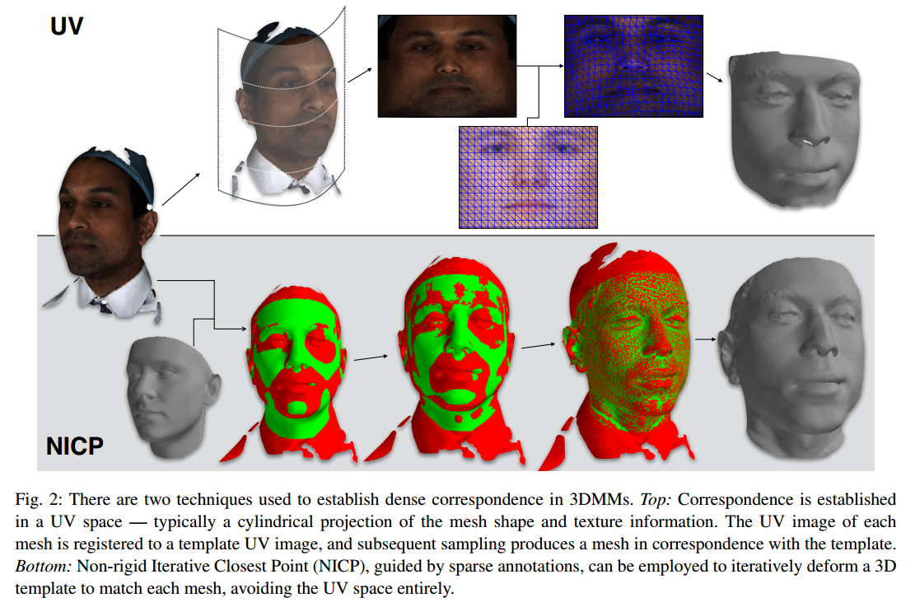
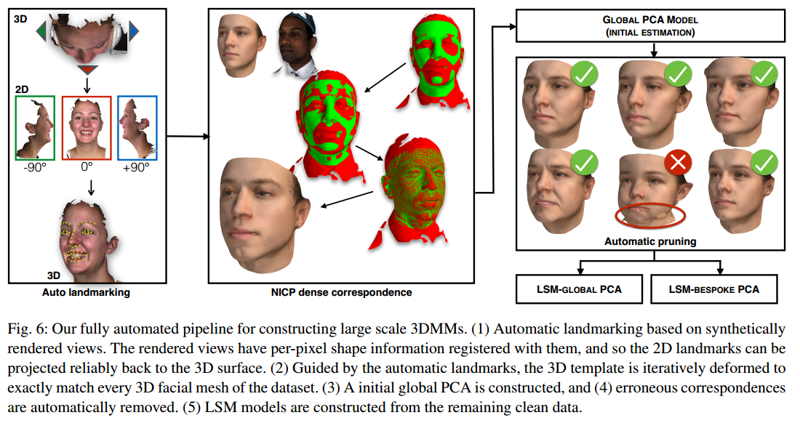

[62] L. Tran and X. Liu. Nonlinear 3d face morphable model. In In Proceeding of IEEE Computer Vision and Pattern Recognition, Salt Lake City, UT, June 2018. 1, 3, 7, 8, 9
[63] L. Tran and X. Liu. On learning 3d face morphable model from in-the-wild images. arXiv:1808.09560, 2018. 1, 2, 3
[59] A. Tewari, M. Zollhofer, P. Garrido, F. Bernard, H. Kim, ¨ P. Perez, and C. Theobalt. Self-supervised multi-level face ‘model learning for monocular reconstruction at over 250 hz.In The IEEE Conference on Computer Vision and Pattern Recognition (CVPR), 2018. 1, 2, 3, 6, 7, 8

FML: Face Model Learning from Videos

Disentangle facial shape, appearance, expression, scene illumination

Flaws of Previous method:
- Data-driven priors required 3D face scans
- Depth ambiguity
- Optimization-based reconstruction rely on a personal model or parametric prior, require ground truth face geometry
Another Fully unsupervised training see in:
(2017 ICCV)MoFA: Model-based Deep Convolutional Face Autoencoder for Unsupervised Monocular Reconstruction

Decoder get input of detailed code vector with face pose, shape, expression, skin reflectance and scene illumination encoded from a CNN-based encoder.

Net work architecture (unsupervised)
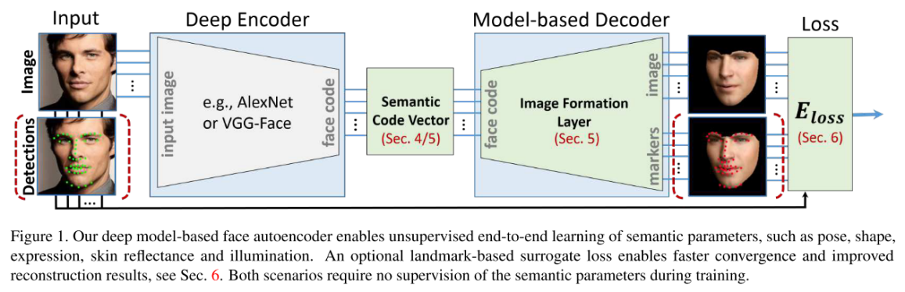

Acquire code vector: CNN network
Reconstruct 3D dense correspondence from code vector: Generative model

CNN Encoder-->model-based decoder + parameterize pose/shape/expression/skin reflectance/illumination-->realistic synthetic image ----> compared with input image --->so it is unsupervised end-to-end model

(2018 arXiv)On learning 3D Face Morphable Model from In-the-wild Images
Contribution: Learn a nonlinear 3DMM model from a large set of in-the-wild face images, without collecting 3D face scans.

Pipeline: Image->feed to network encoder->estimate parameters (projection, lighting, shape and albedo parameters).

Nonlinear 3DMM-like model: 2 decoders
- Decoder1: shape -> 3D shape
- Decoder2: albedo parameters->albedo
Designed a analytically-differentiable rendering layer to reconstruct the original input faces use parameter(projection parameter, lighting, 3D shape, albedo).

Contribution: training a multi-frame video-based self-supervised deep network that:
- Learn a face identity model
- Jointly learning to reconstruct 3D faces
By introduce (1)multiframe consistency loss (consistent shape and appearance across multiple frames of a subject’s face).
Face Identity Model(self-supervised)

Component 2
Component 1

Appearance
(in terms of albedo)
Geometry
(modulo expression)

引用表达：
- Monocular image-based 3D reconstruction of faces is a long-standing problem in computer vision.
- In order to tackle the difficult monocular 3D face reconstruction problem, most existing methods rely on the availability of strong prior models that serve as regularizers for an otherwise ill-posed problem[]
- The same results/limitations: xxx and xxx share the same results/limitations.

